Lesson 18: Inverse Trig Functions
Math 2412 Precalculus · Unit 3: Trigonometric Functions & Triangles · Student Guided Notes
Name: ______________________________ Date: ______________

Lesson objective
Students will define the inverse sine, cosine, and tangent functions on restricted domains, evaluate them exactly and with a calculator, find missing angles in right triangles, and evaluate compositions of trig functions and their inverses.

Before class
Complete these short tasks before the lesson. They review skills this lesson builds on.
- What does it mean for a function to be one-to-one? Why does a function need to be one-to-one to have an inverse? (Lesson 6)
- Give two angles in [0, 2π) with $sin t=\frac{1}{2}$ (Lesson 15).
- A right triangle has legs 3 and 4. Find the hypotenuse and $cos θ$ for the angle across from the side 3 (Lesson 14).

Skill 18.1: Restricted Domains

Key ideas
- Sine, cosine, and tangent are not ______________ (1): each output comes from infinitely many inputs. To define an inverse, we use only one piece of each graph.
- The inverse swaps inputs and outputs: the ______________ (2) of the inverse is the range of the restricted function, and its range is the restricted domain.
- $\sin^{−1} x$ is "the angle whose sine is x." It is also written $arcsin x$. The −1 is not an exponent: $\sin^{−1} x≠\frac{1}{sin x}$.
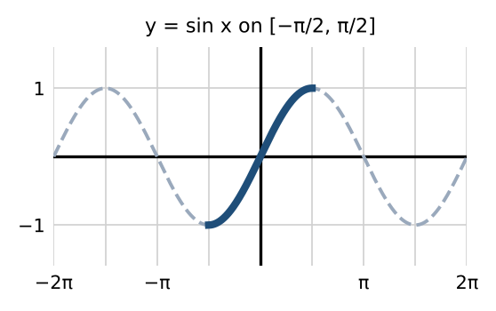 | 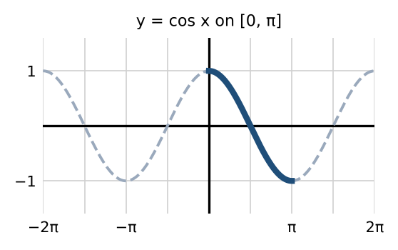

 | Inverse sine | Inverse cosine | Inverse tangent
Notation | $y=\sin^{−1} x$ or $arcsin x$ | $y=\cos^{−1} x$ or $arccos x$ | $y=\tan^{−1} x$ or $arctan x$
Domain | ________ (3) | ________ (4) | ________ (5)
Range | ________ (6) | ________ (7) | ________ (8)

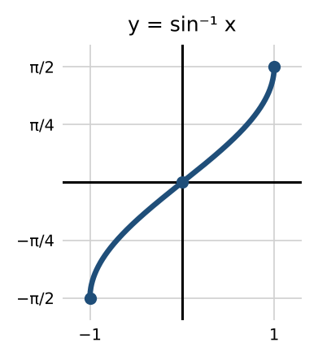 | 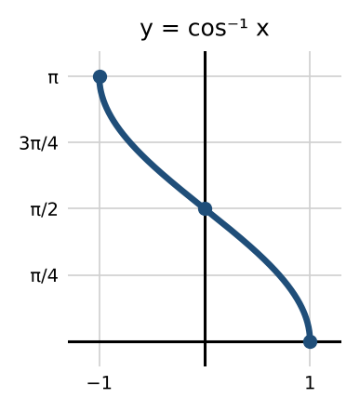

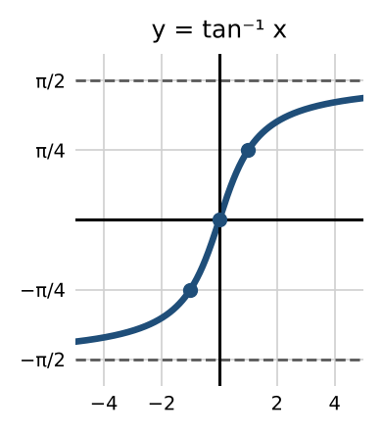

Skill 18.2: Evaluating Inverse Trig Functions

Steps: evaluate $\sin^{−1} a$, $\cos^{−1} a$, or $\tan^{−1} a$ exactly
- Ask which angle has that sine, cosine, or tangent.
- Choose the angle in the range: sine and tangent in quadrant I or IV (negative angles allowed), cosine in quadrant I or II.

Example 1: unit circle values
Expression | Answer | Expression | Answer
$\sin^{−1}(\frac{1}{2})$ | $π/6$ | $\sin^{−1}(−\sqrt{2}/2)$ | ________ (9)
$\cos^{−1}(−\sqrt{3}/2)$ | ________ (10) | $\tan^{−1}(1)$ | ________ (11)
$\sin^{−1}(−1)$ | ________ (12) | $\tan^{−1}(−1)$ | ________ (13)
$\cos^{−1}(−1)$ | ________ (14) | $\cos^{−1}(\frac{1}{2})$ | ________ (15)

Example 2: calculator
In radian mode: $\sin^{−1}(0.97)≈1.3252$ and $\cos^{−1}(−0.4)≈1.9823$. In degree mode: about 75.93° and 113.58°. Check: $\cos^{−1}$ of a negative number is between $π/2$ and π.

Example 3: find the missing angle
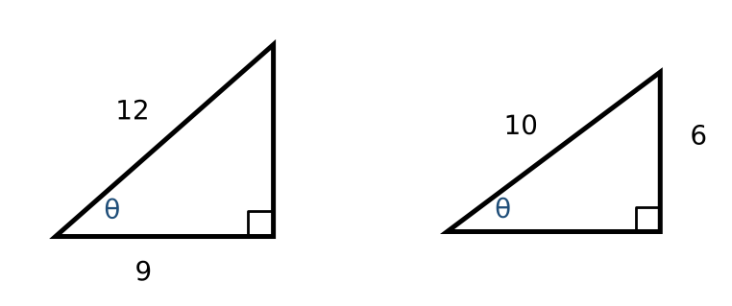
- Left: $cos θ=\frac{9}{12}$, so $θ=\cos^{−1}(\frac{3}{4})≈41.41°$.
- Right: $sin θ=\frac{6}{10}$, so $θ=\sin^{−1}(0.6)≈36.87°$.

Practice
a. Find $\cos^{−1}(\sqrt{2}/2)$ and $\sin^{−1}(\sqrt{3}/2)$. | b. Find $\tan^{−1}(−\sqrt{3})$ and $\cos^{−1}(0)$.
c. Explain why $\sin^{−1}(2)$ is undefined. | d. A ramp rises 2 feet over a horizontal run of 24 feet. Find its angle to the nearest tenth of a degree.

Skill 18.3: Compositions with the Same Function

Key ideas
Sine | Cosine | Tangent
$sin(\sin^{−1} x)=x$ for $−1≤x≤1$ | $cos(\cos^{−1} x)=x$ for $−1≤x≤1$ | $tan(\tan^{−1} x)=x$ for all x
$\sin^{−1}(sin x)=x$ only for ________ (16) | $\cos^{−1}(cos x)=x$ only for ________ (17) | $\tan^{−1}(tan x)=x$ only for ________ (18)

If x is outside the range, evaluate the inside first, then the inverse.

Example
Expression | Work | Answer
$\sin^{−1}(sin(π/3))$ | $π/3$ is in [−π/2, π/2] | $π/3$
$\sin^{−1}(sin(2π/3))$ | $sin(2π/3)=\sqrt{3}/2$, and $\sin^{−1}(\sqrt{3}/2)=π/3$ | ________ (19)
$\cos^{−1}(cos(2π/3))$ | $2π/3$ is in [0, π] | ________ (20)
$\cos^{−1}(cos(−π/3))$ | $cos(−π/3)=\frac{1}{2}$ | ________ (21)
$\tan^{−1}(tan(π/4))$ | $π/4$ is in (−π/2, π/2) | $π/4$
$\tan^{−1}(tan(5π/4))$ | $tan(5π/4)=1$ | ________ (22)
$\sin^{−1}(cos(13π/6))$ | $cos(13π/6)=cos(π/6)=\sqrt{3}/2$ | ________ (23)
$\cos^{−1}(sin(−11π/4))$ | $−11π/4+4π=5π/4$; $sin(5π/4)=−\sqrt{2}/2$ | ________ (24)

Practice
a. Find $\sin^{−1}(sin(5π/6))$. | b. Find $\cos^{−1}(cos(7π/4))$. | c. Find $sin(\sin^{−1}(0.3))$ and $tan(\tan^{−1} 8)$.

Skill 18.4: Compositions with a Reference Triangle

Steps: evaluate $sin(\cos^{−1} a)$ and similar
- Let θ be the inner angle, for example $θ=\cos^{−1}(\frac{4}{5})$, so $cos θ=\frac{4}{5}$ with θ in the range of $\cos^{−1}$.
- Draw a right triangle (in the correct quadrant) with those sides, and find the third side with the Pythagorean theorem.
- Read the outer function from the triangle, with the sign for the quadrant.

Example 1: numbers
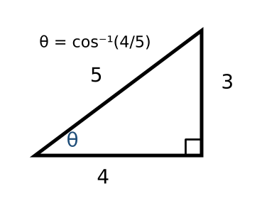
- $sin(\cos^{−1}(\frac{4}{5}))$: adjacent 4, hypotenuse 5, so opposite 3. Answer $\frac{3}{5}$.
- $cos(\tan^{−1}(\frac{5}{12}))$: opposite 5, adjacent 12, so hypotenuse 13. Answer ______________ (25).
- $sin(\tan^{−1}(\frac{7}{4}))$: opposite 7, adjacent 4, so hypotenuse $\sqrt{65}$. Answer ______________ (26).

Example 2: expressions in x
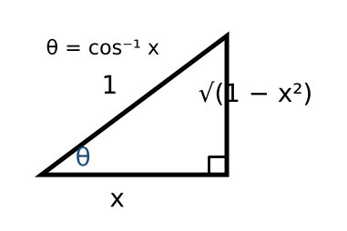
- $sin(\cos^{−1} x)$: adjacent x, hypotenuse 1, opposite $\sqrt{1−x^{2}}$. Answer $\sqrt{1−x^{2}}$.
- $cos(\sin^{−1}(\frac{x}{3}))$: opposite x, hypotenuse 3, adjacent $\sqrt{9−x^{2}}$. Answer ______________ (27).
- $sin(\tan^{−1}(4x))$: opposite 4x, adjacent 1, hypotenuse $\sqrt{16x^{2}+1}$. Answer ______________ (28).

Practice
a. Find $tan(\sin^{−1}(\frac{8}{17}))$. | b. Find $cos(\sin^{−1}(−\frac{3}{5}))$. | c. Write $tan(\cos^{−1} x)$ in terms of x.

Exit check
1. Find $\cos^{−1}(−\frac{1}{2})$.

2. Find $\sin^{−1}(sin(3π/4))$.

3. Find $sin(\cos^{−1}(\frac{5}{13}))$.

